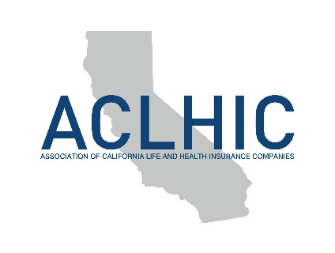

August 24, 2023

The Honorable Gavin Newsom
Governor, State of California
1021 O Street, Suite 9000
Sacramento, CA 95814

SUBJECT: AB-451 Insurance: license examinations – Request for Signature

Dear Governor Newsom,

On behalf of the Association of California Life and Health Insurance Companies (ACLHIC), the California Agents and Health Insurance Professionals (CAHIP), the National Association of Insurance and Financial Advisors of California (NAIFA-California), the American Council of Life Insurers (ACLI), the Independent Insurance Agents and Brokers of California (IIABCal) and the American Property Casualty Insurance Association (APCIA), we respectfully request your signature on AB 451. The bill would require the examination for a license for a life agent, accident and health or sickness agent, property broker-agent, and casualty broker-agent to be provided in English, Spanish, Simplified Chinese, Vietnamese, Korean, and, commencing July 1, 2024, Tagalog.

Given our state’s diverse population and the ever-increasing number of bilingual agents, applicants, and customers, we believe that this commonsense measure expands opportunities for our agents and industry. The option to have the examination administered in several languages will decrease potential miscommunication, increase agent understanding of their duties and obligations, and allow California to keep pace with the needs of its multilingual and multicultural insurance consumers. Also notable, the measure garnered unanimous bipartisan approval in the Legislature.

This simple change in law will enhance agents’ and consumers’ access to critical insurance products and services, and as a result, we respectfully request your signature on AB 451.

Sincerely,

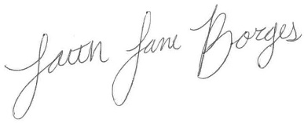

Matthew Powers Faith Lane Borges
Vice-President of Life, Disability and LTC Policy Legislative Advocate
ACLHIC CAHIP

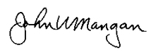

John Mangan Shari McHugh
Regional Vice President, State Relations Legislative Advocate
ACLI NAIFA – CA
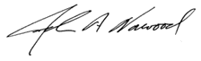
Denni Ritter John Norwood
Vice President, State Government Relations Legislative Advocate
APCIA IIABCal

cc: Assemblymember Lisa Calderon

